1.Create a table listing 3 types of printers, 2 types of scanners, and 2 types of webcams, and for each, write one real-life use case (for example: 'Inkjet printer – printing college assignments').
Answer
- Impact Printer | These printers have a mechanism that touches the paper to create an image. These printers work by banging a print head containing a number of metal pins which strike an inked ribbon placed between the print head and the paper. | Example: the printer’s dot matrix printer. Older printer to
- Ink-jet printers | It is a non-impact printer producing a high quality print. A Standard inkjet printer has a resolution of 300dpi. Newer models have further improved dpi. Inkjet printers were introduced in the latter half of 1980s and are very popular owing to their extra-ordinary performance | Example: this printers creates digital text and images by microscopic printer.
- Laser printers | - Laser printer use very advanced technology and produce a high quality output. Laser printers can also produce high quality graphics images  - Resolution is 600 to 1200dpi. Dots per inch | Example: this printer this newly launcher.

2. Draw a labelled diagram showing how a typical home printer connects to a laptop or PC, including the connection interface used (USB, Wi-Fi, or Bluetooth).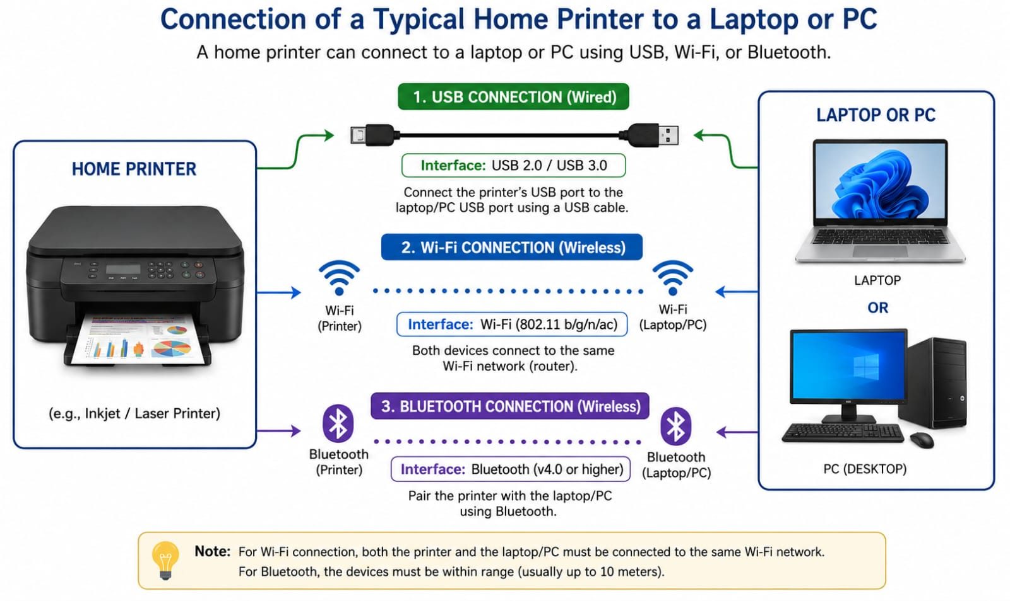

3. List three different connection interfaces (such as USB, Wi-Fi, Bluetooth) used by peripherals like printers, scanners, and webcams, and for each, name one advantage and one disadvantage. Think about speed, convenience, and compatibility.
Connection Interface | Used For | Advantage | Disadvantage
USB | Printer, Scanner, Webcam | Fast data transfer and reliable connection | Requires a cable and limited cable length
Wi-Fi | Printer, Scanner | Wireless convenience; multiple devices can connect | Depends on a stable Wi-Fi network and may be slower than USB
Bluetooth | Printer, Webcam, Keyboard, Mouse | Wireless and easy to pair over short distances | Short range and slower data transfer than USB

4. Pick any one device you use at home or college (printer, scanner, or webcam). Write step-by-step instructions for how you would connect it to your computer, including what cable or wireless method you would use and any setup steps required.
- Connect one end of the USB cable to the printer.
- Connect the other end of the USB cable to a USB port on your computer.
- Wait for the computer to detect the printer automatically.
- If prompted, install the printer driver from the installation CD or download it from the printer manufacturer's website.
- Open Settings → Printers & Scanners (Windows) or System Settings → Printers & Scanners (Mac).
- Click Add a Printer if it is not detected automatically.
- Select your printer from the list and complete the setup.
- Print a test page to confirm that the printer is connected and working correctly
- Turn on the printer and make sure it has paper

